|  |  |  |  |  |  |
| --- | --- | --- | --- | --- | --- |
| Date | 23-Nov-22 | | | Tester Name | Mohammad Yusuf |
| Environment | Select Environment | | | Login used |  |
| Operating System | Select OS | Version: | Update: | | |
| Software Used | Select Software | Version: | Update: | | |
| Select Software | Version: | Update: | | |
| Release version |  | | | | |
| Title | M33.01 Enter Income Tax instructions | | | | |
| Test Type | Regression | | | | |
| Test Scenario | Enter Income Tax instructions | | | | |
|  |  | | | | |
| Expected Results |  | | | | |
| Pass/Fail | Select | | | JIRA# | N/A |

Describe your steps with screenshots:

Navigate to person profile-> Click on Tax instructions

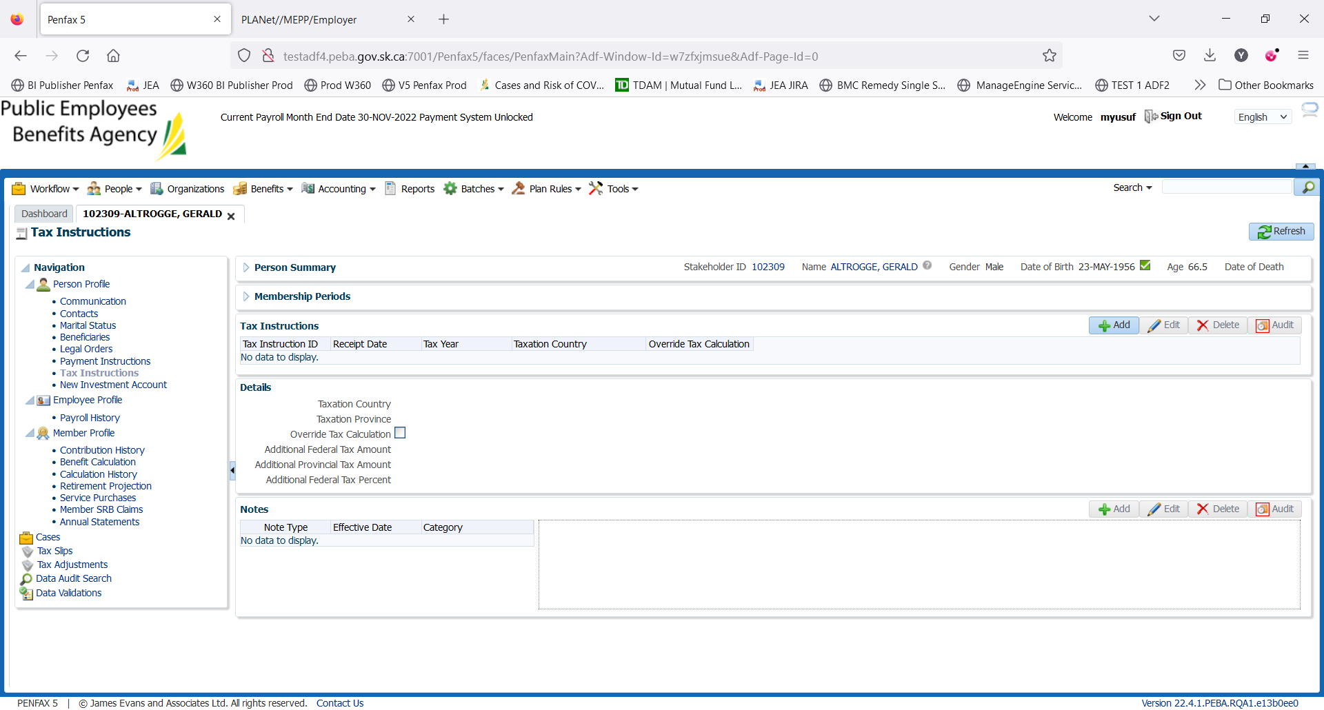

Click on Add

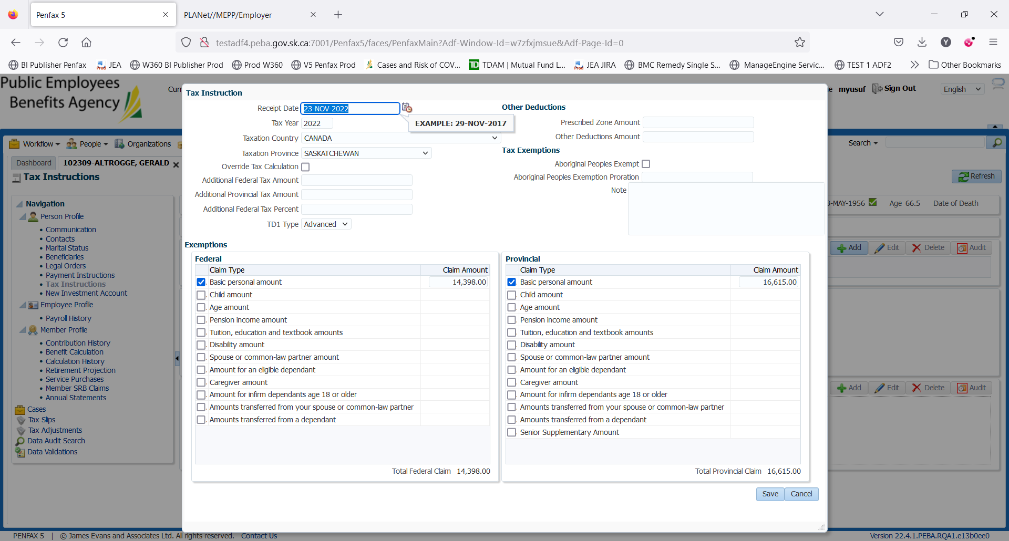

Make desired changes. For example Adding the Age Amt for Federal and Provincial

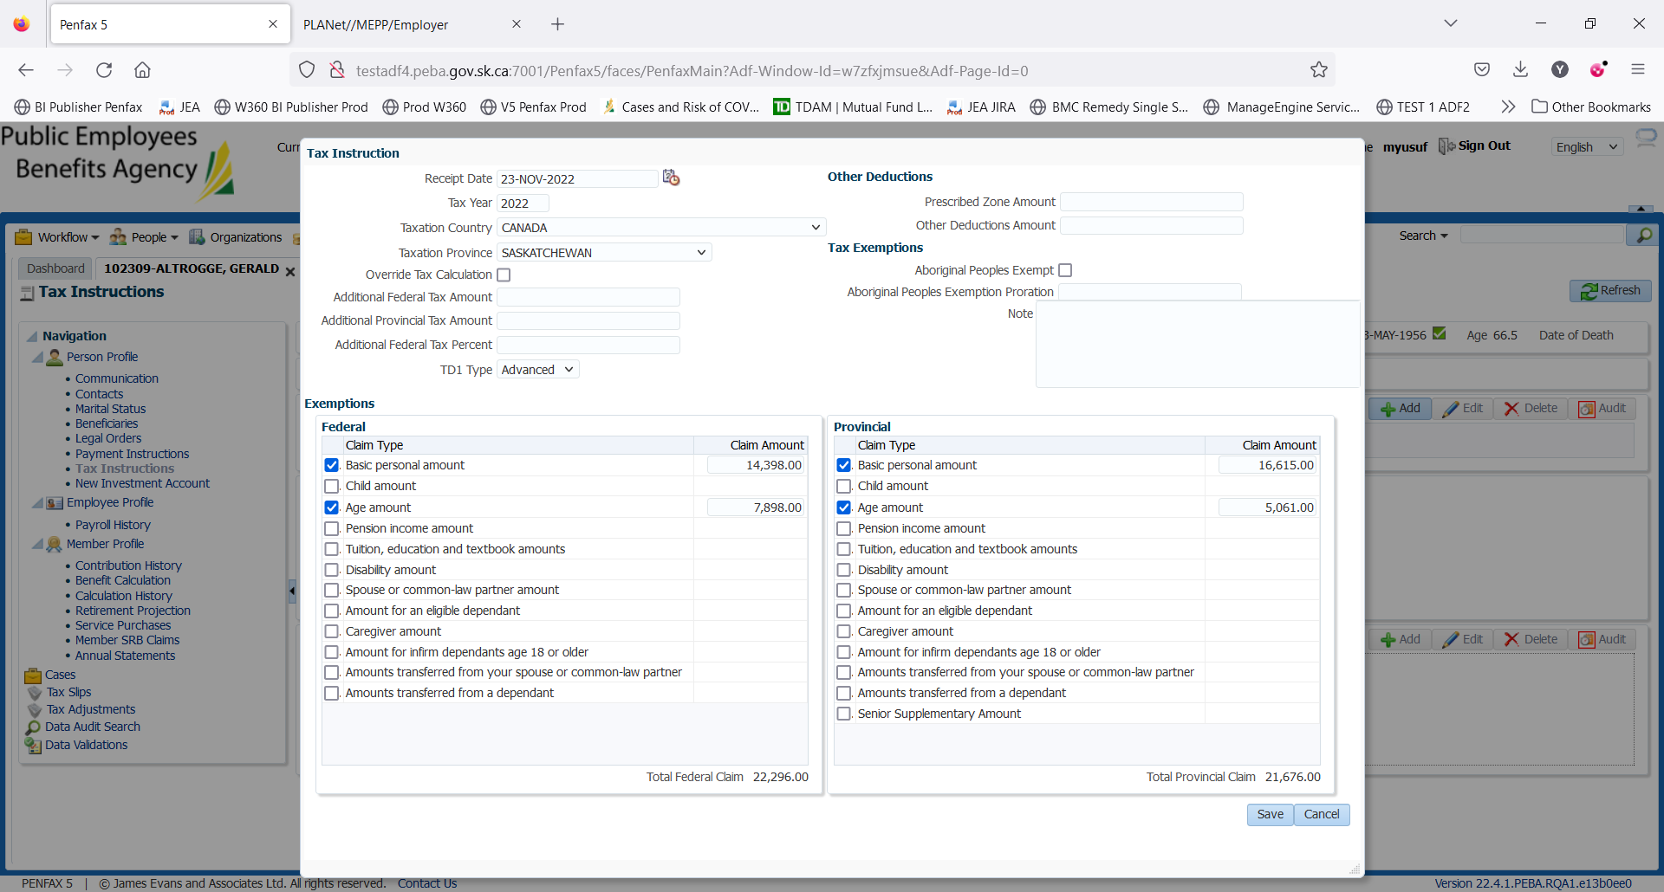

Save and process

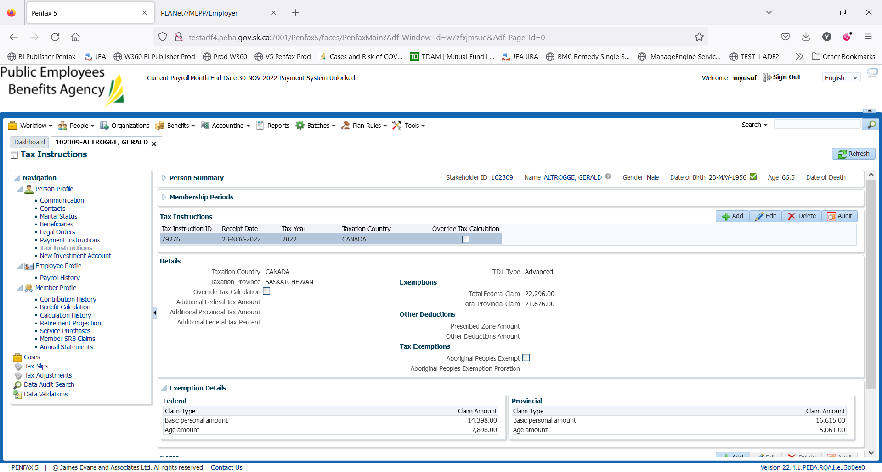

Tax instructions has been added to the stakeholder